**OMEGA TERM E-Note CLASS;J SS1**

**SUBJECT; CULTURAL AND CREATIVE ARTS**

**SCHEME OF WORK**

**WEEK 1**. **COSTUME IN DRAMA.**

**‘’ 2. MOSAIC**

**‘’ 3. THEORY OF MUSIC**

**‘’ 4. INTRODUCTION TO CHOREOGRAPHY**

**‘’ 5. MAKE UPS IN DRAMA**

**‘’ 6-7. CONSEQUENCES OF USING FAKE AND ADULTRATED GOODS**

**‘’ 8. BEAD WORKS**

**‘’ 9. AFRICAN MUSICAL INSTRUMENTS.**

**‘’ 10. TIE – DYE.**

**‘’ 11. PLAYING OF MUSICAL INSTRUMENTS**.

‘**’ 12.** **REVITION AND EXAMINATION**.

**CLASS;J S S 1 WEEK 1** **TOPIC; COSTUME IN DRAMA.**

# **Costume**

[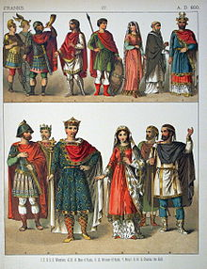](https://en.wikipedia.org/wiki/File:A.D._800,_Franks_-_027_-_Costumes_of_All_Nations_(1882).JPG)

Examples of a range of costumes suitable for specific individuals at a particular epoch.

**Costume** is the distinctive style of dress of an individual or group that reflects their class, gender, profession, ethnicity, nationality, activity or epoch.

The term also was traditionally used to describe typical appropriate [clothing](https://en.wikipedia.org/wiki/Clothing) for certain activities, such as [riding costume](https://en.wikipedia.org/wiki/Riding_habit), [swimming costume](https://en.wikipedia.org/wiki/Swimsuit), [dance costume](https://en.wikipedia.org/wiki/Dance_costume), and [evening costume](https://en.wikipedia.org/wiki/Evening_dress_(disambiguation)). Appropriate and acceptable costume is subject to changes in [fashion](https://en.wikipedia.org/wiki/Fashion) and local cultural norms.

This general usage has gradually been replaced by the terms "dress", "attire" or "wear" and usage of "costume" has become more limited to unusual or out-of-date clothing and to attire intended to evoke a change in identity, such as theatrical, Halloween, and mascot costumes.

Before the advent of ready-to-wear apparel, clothing was made by hand. When made for commercial sale it was made, as late as the beginning of the 20th century, by "costumiers", often women who ran businesses that met the demand for complicated or intimate female costume, including [millinery](https://en.wikipedia.org/wiki/Hatmaking) and [corsetry](https://en.wikipedia.org/wiki/Corsetmaker).

## **Theatrical costume**

[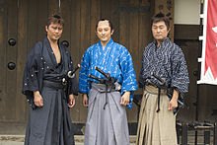](https://en.wikipedia.org/wiki/File:Samurai_actors.jpg) [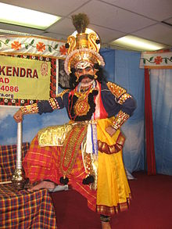](https://en.wikipedia.org/wiki/File:Yakshagana_vesha.jpg) [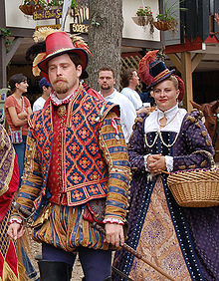](https://en.wikipedia.org/wiki/File:Purpledoublet.jpg)

Costumed performers from the 2006 [Bristol Renaissance Faire](https://en.wikipedia.org/wiki/Bristol_Renaissance_Faire)

"Costume" often refers to a particular style of clothing worn to portray the wearer as a character or type of character at a social event in a [theatrical](https://en.wikipedia.org/wiki/Theatre) [performance](https://en.wikipedia.org/wiki/Performance) on the [stage](https://en.wikipedia.org/wiki/Stagecraft) or in film or television. In combination with other aspects of stagecraft, theatrical costumes can help actors portray characters' and their contexts as well as communicate information about the historical period/era, geographic location and time of day, season or weather of the theatrical performance. Some stylized theatrical costumes, such as [Harlequin](https://en.wikipedia.org/wiki/Harlequin) and [Pantaloons](https://en.wikipedia.org/wiki/Trousers) in the [Commedia dell'arte](https://en.wikipedia.org/wiki/Commedia_dell%27arte), exaggerate an aspect of a character.

## **National costume**

[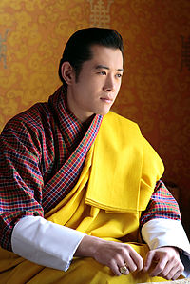](https://en.wikipedia.org/wiki/File:King_Jigme_Khesar_Namgyel_Wangchuck_(edit).jpg) [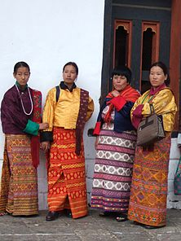](https://en.wikipedia.org/wiki/File:Bhutanese_women_at_festival_wearing_Kira_and_Tego.jpg)

King of Bhutan in traditional dress and Bhutanese Women in traditional dress

[National costume](https://en.wikipedia.org/wiki/National_costume) or regional costume expresses local (or [exiled](https://en.wikipedia.org/wiki/Exile)) [identity](https://en.wikipedia.org/wiki/Identity_(social_science)) and emphasizes a culture's unique attributes. They are often a source of national pride. Examples include the [Scottish](https://en.wikipedia.org/wiki/Scotland) [kilt](https://en.wikipedia.org/wiki/Kilt) or [Japanese](https://en.wikipedia.org/wiki/Japan) [kimono](https://en.wikipedia.org/wiki/Kimono).

In [Bhutan](https://en.wikipedia.org/wiki/Bhutan) there is a traditional national dress prescribed for men and women, including the monarchy. These have been in vogue for thousands of years and have developed into a distinctive dress style. The dress worn by men is known as [Gho](https://en.wikipedia.org/wiki/Gho) which is a robe worn up to knee-length and is fastened at the waist by a band called the [Kera](https://en.wikipedia.org/w/index.php?title=Kera_(clothing)&action=edit&redlink=1). The front part of the dress which is formed like a pouch, in olden days was used to hold baskets of food and short dagger, but now it is used to keep cell phone, purse and the [betel nut](https://en.wikipedia.org/wiki/Betel_nut) called *Doma*. The dress worn by women consist of three pieces known as [Kira](https://en.wikipedia.org/wiki/Kira_(Bhutan)), [Tego](https://en.wikipedia.org/wiki/Toego) and [Wonju](https://en.wikipedia.org/wiki/Wonju). The long dress which extends up to the ankle is Kira. The jacket worn above this is Tego which is provided with Wonju, the inner jacket. However, while visiting the [Dzong](https://en.wikipedia.org/wiki/Dzong) or monastery a long scarf or stoll, called [Kabney](https://en.wikipedia.org/wiki/Kabney) is worn by men across the shoulder, in colours appropriate to their ranks. Women also wear scarfs or stolls called [Rachus](https://en.wikipedia.org/w/index.php?title=Rachus&action=edit&redlink=1), made of raw silk with embroidery, over their shoulder but not indicative of their rank.

**CLASS;JSS1 WEEK 2** **TOPIC;**  **MOSAIC.**

# **Mosaic**

**Mosaic** is the [art](https://en.wikipedia.org/wiki/Art) of creating images with an assemblage of small pieces of colored [glass](https://en.wikipedia.org/wiki/Glass), stone, or other materials. It is a technique of [decorative art](https://en.wikipedia.org/wiki/Decorative_arts) or [interior decoration](https://en.wikipedia.org/wiki/Interior_decoration). Most mosaics are made of small, flat, roughly [square](https://en.wikipedia.org/wiki/Square), pieces of stone or glass of different colors, known as [*tesserae*](https://en.wikipedia.org/wiki/Tesserae); but some, especially floor mosaics, may also be made of small rounded pieces of stone, and called "pebble mosaics"

Mosaic has a long history, starting in [Mesopotamia](https://en.wikipedia.org/wiki/Mesopotamia) in the 3rd millennium BC. Pebble mosaics were made in [Tiryns](https://en.wikipedia.org/wiki/Tiryns) in [Mycenaean](https://en.wikipedia.org/wiki/Mycenean_civilisation) Greece; mosaics with patterns and pictures became widespread in classical times, both in [Ancient Greece](https://en.wikipedia.org/wiki/Ancient_Greece) and [Ancient Rome](https://en.wikipedia.org/wiki/Ancient_Rome). Early Christian [basilicas](https://en.wikipedia.org/wiki/Basilica) from the 4th century onwards were decorated with wall and ceiling mosaics. Mosaic art flourished in the [Byzantine Empire](https://en.wikipedia.org/wiki/Byzantine_Empire) from the 6th to the 15th centuries; that tradition was adopted by the [Norman](https://en.wikipedia.org/wiki/Norman_dynasty) kingdom in [Sicily](https://en.wikipedia.org/wiki/Sicily) in the 12th century, by eastern-influenced [Venice](https://en.wikipedia.org/wiki/Venice), and among the [Rus](https://en.wikipedia.org/wiki/Rus%27_(people)) in Ukraine. Mosaic fell out of fashion in the Renaissance, though artists like [Raphael](https://en.wikipedia.org/wiki/Raphael) continued to practice the old technique. Roman and Byzantine influence led Jews to decorate 5th and 6th century synagogues in the Middle East with floor mosaics.

Mosaic was widely used on religious buildings and palaces in early [Islamic art](https://en.wikipedia.org/wiki/Islamic_art), including Islam's first great religious building, the Dome of the Rock in [Jerusalem](https://en.wikipedia.org/wiki/Jerusalem), and the [Umayyad Mosque](https://en.wikipedia.org/wiki/Umayyad_Mosque) in [Damascus](https://en.wikipedia.org/wiki/Damascus). Mosaic went out of fashion in the Islamic world after the 8th century.

### **Greek and Roman.**

[Bronze age](https://en.wikipedia.org/wiki/Bronze_age) pebble mosaics have been found at [Tiryns](https://en.wikipedia.org/wiki/Tiryns); mosaics of the 4th century BC are found in the [Macedonian](https://en.wikipedia.org/wiki/Macedonia_(ancient_kingdom)) palace-city of [Aegean](https://en.wikipedia.org/wiki/Aegae_(Macedon)), and the 4th-century BC mosaic of [The Beauty of Durres](https://en.wikipedia.org/wiki/The_Beauty_of_Durr%C3%ABs) discovered in [Durres](https://en.wikipedia.org/wiki/Durr%C3%ABs), [Albania](https://en.wikipedia.org/wiki/Albania) in 1916, is an early figural example; the Greek figural style was mostly formed in the 3rd century BC. Mythological subjects, or scenes of hunting or other pursuits of the wealthy, were popular as the Centre pieces of a larger geometric design, with strongly emphasized borders. [Pliny the Elder](https://en.wikipedia.org/wiki/Pliny_the_Elder) mentions the artist [Souses of Pergamum](https://en.wikipedia.org/wiki/Sosus_of_Pergamon) by name, describing his mosaics of the food left on a floor after a feast and of a group of doves drinking from a bowl. Both of these themes were widely copied.

Greek figural mosaics could have been copied or adapted paintings, a far more prestigious art form, and the style was enthusiastically adopted by the Romans so that large floor mosaics enriched the floors of [Hellenistic](https://en.wikipedia.org/wiki/Hellenistic) [villas](https://en.wikipedia.org/wiki/Villa) and Roman dwellings from Britain to [Dura-Europe](https://en.wikipedia.org/wiki/Dura-Europos). Most recorded names of Roman mosaic workers are Greek, suggesting they dominated high quality work across the empire; no doubt most ordinary craftsmen were slaves. Splendid mosaic floors are found in Roman villas across [North Africa](https://en.wikipedia.org/wiki/North_Africa), in places such as [Carthage](https://en.wikipedia.org/wiki/Carthage), and can still be seen in the extensive collection in [Bardo Museum](https://en.wikipedia.org/wiki/Bardo_Museum) in [Tunis](https://en.wikipedia.org/wiki/Tunis), [Tunisia](https://en.wikipedia.org/wiki/Tunisia).

There were two main techniques in Greco-Roman mosaic: [*opus vermiculatum*](https://en.wikipedia.org/wiki/Opus_vermiculatum) used tiny [*tesserae*](https://en.wikipedia.org/wiki/Tesserae), typically cubes of 4 millimeters or less, and was produced in workshops in relatively small panels which were transported to the site glued to some temporary support. The tiny *tesserae* allowed very fine detail, and an approach to the illusionism of painting. Often small panels called *emblematic* were inserted into walls or as the highlights of larger floor-mosaics in coarser work. The normal technique was [*opus tessellatum*](https://en.wikipedia.org/wiki/Opus_tessellatum), using larger tesserae, which was laid on site.[[6]](https://en.wikipedia.org/wiki/Mosaic#cite_note-FOOTNOTESmith1983116.E2.80.93119-6) There was a distinct native Italian style using black on a white background, which was no doubt cheaper than fully coloured work.

### Christian mosaic

#### **Early Christian art**

With the building of Christian [basilicas](https://en.wikipedia.org/wiki/Basilica) in the late 4th century, wall and ceiling mosaics were adopted for Christian uses. The earliest examples of Christian basilicas have not survived, but the mosaics of [Santa Constanza](https://en.wikipedia.org/wiki/Santa_Constanza) and [Santa Pudenziana](https://en.wikipedia.org/wiki/Santa_Pudenziana), both from the 4th century, still exist. The winemaking putti in the [ambulatory](https://en.wikipedia.org/wiki/Ambulatory) of Santa Constanza still follow the classical tradition in that they represent the feast of [Bacchus](https://en.wikipedia.org/wiki/Bacchus), which symbolizes transformation or change, and are thus appropriate for a mausoleum, the original function of this building. In another great Constantine basilica, the [Church of the Nativity](https://en.wikipedia.org/wiki/Church_of_the_Nativity) in Bethlehem the original mosaic floor with typical Roman geometric motifs is partially preserved. The so-called [Tomb of the Julii](https://en.wikipedia.org/wiki/Tomb_of_the_Julii), near the crypt beneath [St Peter's Basilica](https://en.wikipedia.org/wiki/St_Peter%27s_Basilica), is a 4th-century vaulted tomb with wall and ceiling mosaics that are given Christian interpretations. The [Rotunda of Galerius](https://en.wikipedia.org/wiki/Arch_of_Galerius_and_Rotunda) in [Thessaloniki](https://en.wikipedia.org/wiki/Thessaloniki), converted into a Christian church during the course of the 4th century, was embellished with very high artistic quality mosaics. Only fragments survive of the original decoration, especially a band depicting saints with hands raised in prayer, in front of complex architectural fantasies.

**CLASS;JSS1 WEEK 3 TOPIC; THEORY OF MUSIC**

Sight Singing: A Beginner’s Guide

[Meghan Nixon](http://www.howtosingsmarter.com/author/meghanmckowngmail-com/)[5 Comments](http://www.howtosingsmarter.com/sight-singing/#comments)

March 11, 2016

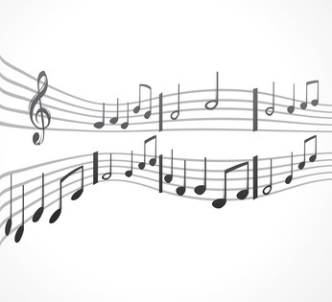

**0**

Have you always wanted to learn to sight sing/read music? If you learn how to sight sing, you’ll be able to pick up a piece of music you’ve never seen or heard before and sing it on the spot.

I’ve put together a beginner’s tutorial on sight singing to get you started. All of these concepts have much deeper levels that we will explore in future posts. For now, I’m going to teach you the basics of what you need to know to start sight singing some simple melodies TODAY!

**Sight Singing Step #1**

The first step to becoming a good sight singer is to know your way around the major scale. You should be able to sing it a capella and in tune on solfege syllables. If you need some help with this, check out this video & article –  [How To Sing And Play The Major Scale](http://www.howtosingsmarter.com/major-scale/)

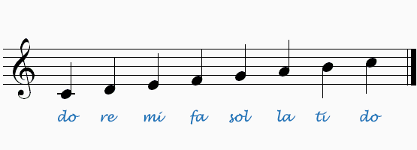

**Sight Singing Step #2**

The second step is learning the [names of the notes on the staff](http://www.howtosingsmarter.com/treble-clef-notes-bass-clef-notes/) (treble clef most importantly). Most vocal music (other than baritone and bass parts in choral music) is written in treble clef.

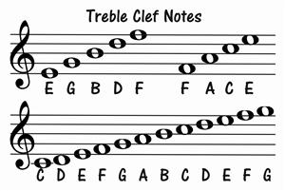

Lines- **E**very **G**ood **B**oy**D**eserves **F**udge

Spaces-**FACE**

**Sight Singing Step #3**

The third step is learning basic rhythmic values. When you read music, the notes on the page represent pitch as well as rhythm.

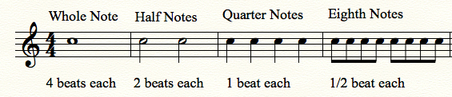

Audio Player

**Rests are periods of silence in music.**They work the same way that notes do, except they represent silence instead of sound. For example, a quarter note is a pitch that lasts for 1 beat. A quarter rest is silence that lasts for 1 beat.

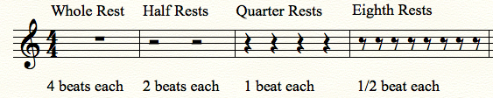

**Sight Singing Step #4**

Time signatures and Key signatures. **For now, we are going to keep it simple and focus only on  4/4 time and the key of C Major.**

(I will be posting full tutorials on time signatures and key signature in the near future.)

***What is a time signature?***

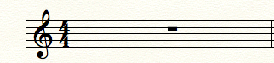

You can find the time signature at the beginning of a piece of music. It looks like a fraction- two number stacked on top of each other. The top number in the time signature tell you how many beats are in each measure of music. A song with a time signature of 4/4 has four quarter note beats per measure.

 Example-

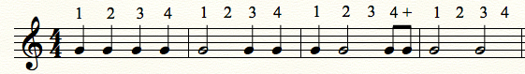

***What is a key signature?***

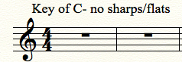

A key signature is a set of sharp or flat symbols placed together on the music staff. You can find the key signature at the beginning of a piece of music- right between the clef sign and the time signature. The key signature tells you what key the piece of music is in and what notes are sharp or flat in that particular key.

Examples of other key signatures-

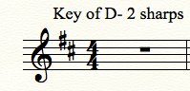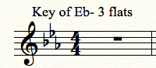

Key signatures might seem complicated, but really it’s just memorization. The goal is to be able to look at a key signature and think “Ah yes- I see three flats in that key signature. This song is in the key of Eb Major.” [Here is a link to a great tutorial on key signatures.](http://musictheoryfundamentals.com/MusicTheory/keySignatures.php)

**Sight Singing Step #5**

Practice! Here are some sight singing exercises to get you started.

Your first note is C-

Audio Player.

# Basic Music Theory

**Ever wondered why music theory didn't make sense?** The key to learning basic music theory is to learn and use the same systems that all musicians use.

Music is a language. It has parts that make up the whole, and those parts are made of even smaller parts. This sentence is made of words, and these words are made of letters. To learn how to make the sentence as a whole, you have to learn the letters of the alphabet, and learn how to put them into words. Then you have to learn certain words, and learn how to put them into sentences.

Music works the same way. You learn the alphabet then put those pieces together to make musical phrases, then put those together to make a song.

[**Alphabet**](http://www.music-theory-for-musicians.com/music-alphabet.html)   
The music alphabet is like the English alphabet. It is a system of letters that are assigned to represent sounds in music that we call notes. This is the simplest part to learn, and everything else will be based on this, so start here!

[**Scales**](http://www.music-theory-for-musicians.com/music-scales.html)   
Scales are just a linear arrangement of notes. If notes are actual pitches, then scales are those pitches in a certain order. (ex. A B C D E F G) because scales or pieces of scales are used in just about every song ever written, they are a huge piece of basic music theory.

[**Intervals**](http://www.music-theory-for-musicians.com/music-theory-intervals.html)    
An Interval is the distance from one note to another. Whether it's B to C (a Second) or G# to Eb (a Sixth), every interval has its own name. This stuff is really useful in figuring out harmonies.   
  
[**Chords**](http://www.music-theory-for-musicians.com/music-theory-chords.html)  
Chords are certain members of a scale combined into one sound. (For instance "C + E + G = CMaj" or "D + F + A = DMin".) Chords give structure, organization, and shape to a song. They make the song "sound" a certain way. Even if you are strictly a lead player, you NEED to know this. Even as a violinist, I use chords all the time to talk about the songs. *I'll play that fill after the G7 chord.*

[**Key Signatures**](http://www.music-theory-for-musicians.com/key-signatures.html)   
Key signatures tell us the tonality or "key" of a song. It also tells us which notes the song will be using. The more you work with these, the more familiar you get with the range and scale of particular keys. Unless you want all of your songs to sound the same, PLEASE study these.

**CLASS; J S S 1 WEEK 4**

**TOPIC; INTRODUCTION TO CHOREOGRAPHY**

# **Choreography**

[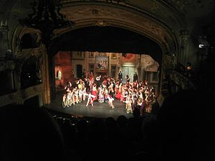](https://en.wikipedia.org/wiki/File:Choreographed_Opera_Performance_(Carmen_by_Bizet).jpg)

**Choreography** is the [art](https://en.wikipedia.org/wiki/Art) or practice of designing [sequences](https://en.wikipedia.org/wiki/Sequence) of movements of physical bodies (or their depictions) in which [motion](https://en.wikipedia.org/wiki/Motion_(physics)), [form](https://en.wikipedia.org/wiki/Visual_appearance), or both are specified. *Choreography* may also refer to the [design](https://en.wikipedia.org/wiki/Design) itself.

A **choreographer** is one who creates choreographies by practicing the art of choreography, a process known as *choreographing*. Choreography is used in a variety of fields, including [cheerleading](https://en.wikipedia.org/wiki/Cheerleading), [cinematography](https://en.wikipedia.org/wiki/Cinematography), [gymnastics](https://en.wikipedia.org/wiki/Gymnastics), [fashion shows](https://en.wikipedia.org/wiki/Fashion_shows), [ice skating](https://en.wikipedia.org/wiki/Ice_skating), [marching band](https://en.wikipedia.org/wiki/Marching_band), [show choir](https://en.wikipedia.org/wiki/Show_choir), [theatre](https://en.wikipedia.org/wiki/Theatre), [synchronized swimming](https://en.wikipedia.org/wiki/Synchronized_swimming), [cardistry](https://en.wikipedia.org/wiki/Cardistry), video game production and animated art. In the [performing arts](https://en.wikipedia.org/wiki/Performing_arts), choreography applies to human movement and form. In [dance](https://en.wikipedia.org/wiki/Dance), choreography is also known as [dance choreography](https://en.wikipedia.org/wiki/Choreography_(dance)) or *dance composition*.

The word *choreography* literally means "dance-writing" from the Greek words (circular dance, see [chorea](https://en.wikipedia.org/wiki/Choreia_(dance))) and (writing). It first appeared in the American English dictionary in the 1950s, and "choreographer" was first used as a credit for [George Balanchine](https://en.wikipedia.org/wiki/George_Balanchine) in the Broadway show [*On Your Toes*](https://en.wikipedia.org/wiki/On_Your_Toes) in 1936. Prior to this, stage credits and movie credits used phrases such as "ensembles staged by", "dances staged by", or simply "dances by" to denote the choreographer.

# **Choreography (dance)**

In dance, **choreography** is the act of designing [dance](https://en.wikipedia.org/wiki/Dance). *Choreography* may also refer to the [design](https://en.wikipedia.org/wiki/Design) itself, which is sometimes expressed by means of [dance notation](https://en.wikipedia.org/wiki/Dance_notation). A *choreographer* is one who designs dances. Dance [choreography](https://en.wikipedia.org/wiki/Choreography) is sometimes called *dance composition*.

Aspects of dance choreography include the compositional use of [organic unity](https://en.wikipedia.org/wiki/Organic_unity), rhythmic or non-rhythmic articulation, theme and variation, and repetition. The choreographic process may employ [improvisation](https://en.wikipedia.org/wiki/Improvisation) for the purpose of developing innovative movement ideas. In general, choreography is used to design dances that are intended to be performed as [concert dance](https://en.wikipedia.org/wiki/Concert_dance).

The art of choreography involves the specification of human movement and form in terms of space, shape, time and energy, typically within an [emotional](https://en.wikipedia.org/wiki/Emotion) or non-literal context. Movement language is taken from the dance techniques of [ballet](https://en.wikipedia.org/wiki/Ballet), [contemporary dance](https://en.wikipedia.org/wiki/Contemporary_dance), [jazz dance](https://en.wikipedia.org/wiki/Jazz_dance), [hip hop dance](https://en.wikipedia.org/wiki/Hip_hop_dance), [folk dance](https://en.wikipedia.org/wiki/Folk_dance), [techno](https://en.wikipedia.org/wiki/Techno), [k pop](https://en.wikipedia.org/wiki/K_pop), religious dance, pedestrian movement, or combinations of these.

**Techniques**

Dances are designed by applying one or both of these fundamental choreographic methods:

# [Principles of Choreograph a Dance](http://www.wikihow.com/Choreograph-a-Dance)

Choreographing a dance requires creativity, patience, and hard work! Before you piece together the perfect routine, let the music and genre inspire you. Be confident in your steps and the skills of your performers. Most importantly, have fun! Rehearse and perform your piece with confidence.

**1**

**Spend some time thinking about your routine.** Is there a specific message you wish to get across or a mood you hope to convey. Keep track of your thoughts and ideas in a journal, on your computer, or in a notes app on your phone. As you begin choreographing, refer to these early brainstorming sessions for inspiration and direction.

* Get inspired by other performances. Devote sometime to watching street performers, YouTube videos, and classical recitals. Watch old musicals and modern music videos.

**2**

**Take your audience, venue, and event into consideration.** When choreographing a dance, it is important to know your audience. Who are you performing for? What kind of dance are they expecting? As a choreographer, it is also essential that you take the venue and event into consideration. Will the dancers be on a stage, on a gym floor, or outdoors? Will your piece be performed at a recital or at the halftime of your high school’s basketball game? The answers to these questions will influence the content of your dance number.

**3**

**Select a style.** There are hundreds of styles to choose between. You could choreograph a hip-hop routine or a fiery flamenco. Pick a style that suits your skills and the talents of your dancers. If you’re feeling daring, try creating a mash-up. Combine and mesh multiple styles into one stellar routine.

* Choose a style that is fun and that you and your dancers are comfortable with.

**4**

**Choose a song.** Selecting a song that complements the dance style is essential. While classical songs work well for ballet, hip-hop routines generally require more modern tunes. The song should inspire your creativity, motivate you to move, and intrigue your audience.

* Don’t be afraid to select an out-of-the-box song. Sometimes taking a risk can be very rewarding. Listen to new artists or artists from different countries.

**5**

**Determine how many dancers will perform your piece.** Are you creating a beautiful solo or a daring duet? Do you feel inspired to create a complex group number or a dance simple enough for a flash mob? Decide how many dancers you will need in order to convey your message to the audience.

* Be flexible! If your dancers are volunteers, you may not get as many willing participants as you had originally hoped.

* **Improvisation** in choreography is the process in which a choreographer provides dancers with a *score* (i.e., generalized directives) that serves as guidelines for improvised movement and form. For example, a score might direct one dancer to withdraw from another dancer, who in turn is directed to avoid the withdrawal, or it might specify a sequence of movements that are to be executed in an improvised manner over the course of a musical phrase, as in [contra dance choreography](https://en.wikipedia.org/wiki/Contra_dance_choreography). Improvisational scores typically offer wide latitude for personal interpretation by the dancer.
* **Planned choreography**, in which a choreographer dictates motion and form in detail, leaving little or no opportunity for the dancer to exercise personal interpretation.

**CLASS;J S S 1 WEEK 5**

**TOPIC; MAKE UP IN DRAMA**

Makeup refers to things that is used to assist in creating the appearance of the [characters](https://en.wikipedia.org/wiki/Character_(arts)) that [actors](https://en.wikipedia.org/wiki/Actors) portray during a theater production.

[[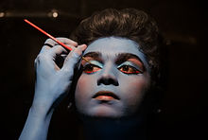](https://en.wikipedia.org/wiki/File:Self_make_up_by_an_artist.jpg)](https://en.wikipedia.org/wiki/File:Self_make_up_by_an_artist.jpg)

**Make-up**, also known as **Cosmetics** , are substances or products used to enhance or alter the [appearance](https://en.wikipedia.org/wiki/Human_physical_appearance) or [fragrance](https://en.wikipedia.org/wiki/Aroma_compound) of the body. Many cosmetics are designed for use of applying to the face and hair. They are generally mixtures of [chemical compounds](https://en.wikipedia.org/wiki/Chemical_compound); some being derived from natural sources (such as [coconut oil](https://en.wikipedia.org/wiki/Coconut_oil)), and some being synthetics.[[1]](https://en.wikipedia.org/wiki/Cosmetics#cite_note-Ullmann-1) Common cosmetics include [lipstick](https://en.wikipedia.org/wiki/Lipstick), [mascara](https://en.wikipedia.org/wiki/Mascara), [eye shadow](https://en.wikipedia.org/wiki/Eye_shadow), [foundation](https://en.wikipedia.org/wiki/Foundation_(cosmetics)), [rouge](https://en.wikipedia.org/wiki/Rouge_(cosmetics)), [skin cleansers](https://en.wikipedia.org/wiki/Cleanser) and [skin lotions](https://en.wikipedia.org/wiki/Lotion), [shampoo](https://en.wikipedia.org/wiki/Shampoo), [hairstyling products](https://en.wikipedia.org/wiki/Hairstyling_product) ([gel](https://en.wikipedia.org/wiki/Hair_gel), [hair spray](https://en.wikipedia.org/wiki/Hair_spray), etc.), [perfume](https://en.wikipedia.org/wiki/Perfume) and [cologne](https://en.wikipedia.org/wiki/Eau_de_Cologne).

In the U.S., the [Food and Drug Administration](https://en.wikipedia.org/wiki/Food_and_Drug_Administration) (FDA), which regulates cosmetics defines cosmetics as "intended to be applied to the human body for cleansing, beautifying, promoting attractiveness, or altering the appearance without affecting the body's structure or functions". This broad definition includes any material intended for use as a [component](https://en.wiktionary.org/wiki/component) of a cosmetic product. The FDA specifically excludes [soap](https://en.wikipedia.org/wiki/Soap) from this category.

## **TYPES**

Cosmetics are intended to be applied externally. They include but are not limited to products that can be applied to the face: [skin](https://en.wikipedia.org/wiki/Human_skin)-care [creams](https://en.wikipedia.org/wiki/Cream_(pharmaceutical)), [lipsticks](https://en.wikipedia.org/wiki/Lipstick), [eye](https://en.wikipedia.org/wiki/Human_eye) and facial makeup, [towe lettes](https://en.wikipedia.org/wiki/Wet_wipe), and [colored contact lenses](https://en.wikipedia.org/wiki/Colored_contact_lenses); to the body: [deodorants](https://en.wikipedia.org/wiki/Deodorant), [lotions](https://en.wikipedia.org/wiki/Lotion), [powders](https://en.wikipedia.org/wiki/Powder_(substance)), [perfumes](https://en.wikipedia.org/wiki/Perfume), baby products, bath oils, [bubble baths](https://en.wikipedia.org/wiki/Bubble_bath), [bath salts](https://en.wikipedia.org/wiki/Bath_salts), and body [butters](https://en.wikipedia.org/wiki/Butter); to the hands/nails: fingernail and toe [nail polish](https://en.wikipedia.org/wiki/Nail_polish), and [hand sanitizer](https://en.wikipedia.org/wiki/Hand_sanitizer); to the hair: permanent chemicals, [hair](https://en.wikipedia.org/wiki/Hair) [colors](https://en.wikipedia.org/wiki/Hair_coloring), [hair sprays](https://en.wikipedia.org/wiki/Hair_spray), and [gels](https://en.wikipedia.org/wiki/Gel).

A subset of cosmetics is called "make-up", refers primarily to products containing color pigments that are intended to alter the user's appearance. Manufacturers may distinguish between "decorative" and "care" cosmetics.

Cosmetics that are meant to be used on the face and eye area are usually applied with a brush, a makeup sponge, or the fingertips.

Most cosmetics are distinguished by the area of the body intended for application.

* [Primer](https://en.wikipedia.org/wiki/Primer_(cosmetics)) comes in formulas to suit individual skin conditions. Most are meant to reduce the appearance of pore size, prolong the wear of makeup, and allow for a smoother application of makeup. Primers are applied before foundation or eyeshadows depending on where the primer is to be applied.
* [Lipstick](https://en.wikipedia.org/wiki/Lipstick), [lip gloss](https://en.wikipedia.org/wiki/Lip_gloss), [lip liner](https://en.wikipedia.org/wiki/Lip_liner), [lip plumper](https://en.wikipedia.org/wiki/Lip_augmentation), [lip balm](https://en.wikipedia.org/wiki/Lip_balm), lip stain, lip conditioner, lip primer, lip boosters, and lip butters: Lipsticks are intended to add color and texture to the lips and often come in a wide range of colors, as well as finishes such as matte, satin, and lustre. Lip stains have a water or gel base and may contain alcohol to help the product stay on leaving a matte look. They temporarily saturate the lips with a dye. Usually designed to be waterproof, the product may come with an applicator [brush](https://en.wikipedia.org/wiki/Makeup_brush), rollerball, or could be applied with a finger. Lip glosses are intended to add shine to the lips and may add a tint of color, as well as being scented or flavored for a pop of fun. Lip balms are most often used to moisturize, tint, and protect the lips. Some brands contain [sunscreen](https://en.wikipedia.org/wiki/Sunscreen).
* [Concealer](https://en.wikipedia.org/wiki/Concealer) makeup covers imperfections of the skin. Concealer is often used for any extra coverage needed to cover blemishes, under eye circles, and other imperfections. Concealer is often thicker and more solid than foundation, and provides longer lasting, more detailed coverage as well as creating a fresh clean base for all the rest of the makeup.

. Some formulations are intended only for the eye or only for the face. This product can also be used for contouring the face like ones nose, cheekbones, and jaw line to add a more defined look to the total face.

* [Foundation](https://en.wikipedia.org/wiki/Foundation_(cosmetics)) is used to smooth out the [face](https://en.wikipedia.org/wiki/Face) and cover spots, acne, blemishes, or uneven skin coloration. These are sold in a liquid, cream, or powder, or most recently a mousse. Foundation provides coverage from sheer to matt to dewey or full.[[2]](https://en.wikipedia.org/wiki/Cosmetics#cite_note-USHealthandHuman-2) Foundation primer can be applied before or after foundation to obtain a smoother finish. Some primers come in powder or liquid form to be applied before foundation as a base, while other primers come as a spray to be applied after the foundation to set the make-up and help it last longer throughout the day.
* [Face powder](https://en.wikipedia.org/wiki/Face_powder) sets the foundation, giving it a [matte](https://en.wiktionary.org/wiki/Special:Search/matte) finish, and to conceal small flaws or blemishes. It can also be used to [bake](https://en.wikipedia.org/wiki/Baking_(make-up)) the foundation, so that it stays on longer. Tinted face powders may be worn alone as a light foundation so that the full face does not look as caked-up as it could.
* [Rouge, blush, or blusher](https://en.wikipedia.org/wiki/Rouge_(cosmetics)) is cheek coloring to bring out the color in the [cheeks](https://en.wikipedia.org/wiki/Cheek) and make the [cheekbones](https://en.wikipedia.org/wiki/Zygomatic_bone) appear more defined. Rouge comes in powder, cream, and liquid forms. Different blush colors are used to compliment different skin tones.
* Contour powders and creams are used to define the face. They can give the illusion of a slimmer face or to modify a face shape in other desired ways. Usually a few shades darker than the skin tone and matte in finish, contour products create the illusion of depth. A darker-toned foundation/concealer can be used instead of contour products for the same purpose.
* Highlight, used to draw attention to the high points of the face as well as to add glow, comes in liquid, cream, and powder forms. It often contains a substance to provide shimmer. Alternatively, a lighter-toned foundation/concealer can be used.
* [Bronzer](https://en.wikipedia.org/wiki/Bronzer) gives skin a bit of color by adding a golden or bronze glow and highlighting the cheekbones, as well as being used for contouring. Bronzer is considered to be more of a natural look and can be used for an everyday wear. Bronzer enhances the color of the face while adding more of a shimmery look. It comes in either matte, semi matte/satin, or shimmer finishes.

## **Straight makeup**

### Skin

If a performer’s skin is perfectly toned, makeup spreads smoothly and adheres easily. Dry skin or oily skin is dealt with prior to makeup application; otherwise, the makeup appears blotchy or smeared due to variations in absorption. Performers with dry skin use a moisturizer daily and after their faces have been cleansed following a performance. Performers with oily complexions use a facial [toner](https://en.wikipedia.org/wiki/Toner_(skin_care)) wipe or [astringent](https://en.wikipedia.org/wiki/Astringent) to remove the oil and allow a smooth application.

Skin has four basic tones: brown, fair, pink and olive. Individuals with fair, pink, and olive skin tones use olive, beige, or suntan bases. Makeup artist and performers select shades compatible with the natural skin tone, but the base is one to several shades deeper. Performers with predominately pink or ruddy complexions use base colors with cool undertones. The character, size of the theatre, and light intensity will determine the tone depth of the foundation.

A thin layer of base makeup is applied to the neck, ears, and face using a white rubber sponge or fingers. A heavy application of base appears aged and creepy.

### **Rouge**

Fair complexions are enhanced by soft shades of peach and pink, while brown complexions are best accented with coral shades. Moist rouge is applied before powder; dry rouge is used to accent the already powdered makeup.

### **Eyes**

Eyes and eyebrows are the greatest communicative tool in an actor’s arsenal. They are the most expressive feature on the face.

Grease or stick shadow is applied to the eyelids and blended out toward the eyebrow bone before powder is applied; dry eye shadow is used alone or to intensify and touch up the color underneath. Dark eye shadow or grease deepens the eye sockets, creating a skull-like effect. Shades of brown and gray are best for individuals with fair complexions. Individuals with brown complexions use lighter shadows such as toast, mushroom or soft yellows.

#### **Eye liner**

Liquid eyeliner, cake eyeliner, or the eyebrow pencil is used to accent and frame the eyes. There are two ways to line the upper lid of the eye: the owl eye or the almond eye. The owl eye is used to widen the eye and involves using a heavier line in the middle of the lid. The almond-shaped eye is created by extending the line out beyond the outer corner of the eye. The lower line is created by using the same tool used on the upper lid. The line begins a quarter-inch from the inner corner of the eye. This extra space is needed to open the eye.

**Eyelashes**

Mascara is used to add extra attention to the eyes. Black lash mascara is the most popular and commonly used by women with fair and brown complexions. Very fair individuals and men use brown mascara. The bottom lashes are coated with mascara and to avoid using false lashes, a process of layering powder and mascara is used to provide greater thickness.

### **Powder**

A generous amount of powder is needed to reduce unwanted shine. If a performer’s makeup is under-powdered, his skin oils will break through quickly, producing shine and possibly running. After powder is applied to the entire face, starting under and around the eyes, it is gently pressed for thirty seconds. The excess is brushed off with a large soft brush or piece of cotton. A wet natural sponge or cotton is wiped lightly across the face to set the makeup, to remove any visible powder, and to eliminate the mask feeling.

[Translucent](https://en.wiktionary.org/wiki/translucent#Pronunciation) powders are used for fair complexions because they do not alter the original color of the base, the under-rouge, or the moist eye shadow. Brown complexions are set with tinted that is compatible with the base color. It is used sparingly over the under-rouge and moist eye shadow. After the powder is applied, dry eye shadow and dry rouge are added.

### Lips

[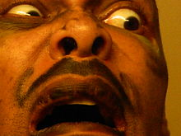](https://en.wikipedia.org/wiki/File:Stage_makeup.JPG)

Applied makeup to the lips and cheeks assisting in the conveyance of emotion.

Though the eyes are the most expressive feature of the face, the eyes and ears of the audience follow mouth movements to understand a play’s progression. If a performer’s lips are underdone or overplayed, they will detract from the performer and the performance. A general rule is: the larger the mouth, the deeper the lipstick tone. However, the actor should not appear “all mouth”.

Fair complexions use shades of lipstick like pink and coral. Brown complexions are enhanced by coral and orange shades. Red lipsticks are reserved for large theatres and character portrayals. An auburn or brown pencil are used to provide definition to the lips. Lipsticks on men can look doll-like. Men use natural-colored lipsticks, lightly applied.

**Makeup and lighting**

Lighting controls makeup to a high degree. Makeup can lose its effectiveness due to incorrect stage lighting. Conversely, skillful lighting can greatly aid the art of makeup. Close communication between the lighting director and the makeup artist is crucial for the best possible effect.

Understanding light's effect on makeup and various shades and pigments is important when designing a performer’s makeup. The following are among the basic rules of light: nothing has color until light is reflected from it; an object appears black when all of the light is absorbed; an object appears white when all of the light is reflected. If certain rays are absorbed and others are reflected, the reflected rays determine the color.

**CLASS; J S S 1 WEEK 6 -7**

**TOPIC; CONSEQUENCES OF USING FAKE AND ADULTRATED GOODS**

# **Adulterant**

# **An adulterant** is a pejorative term for a substance found within other substances such as [food](https://en.wikipedia.org/wiki/Food), [fuels](https://en.wikipedia.org/wiki/Fuel) or chemicals, although not allowed for legal or other reasons. It will not normally be present in any specification or declared contents of the substance, and may not be legally allowed. The addition of adulterants is called adulteration. The most common reason for adulteration is the use by manufacturers of undeclared materials that are cheaper than the correct and declared ones. The adulterants may be harmful, or reduce the potency of the product, or they may be harmless.

**"Adulteration"** is a legal term meaning that a food product fails to meet federal or state standards. Adulteration is an addition of another substance to a food item in order to increase the quantity of the food item in raw form or prepared form, which may result in the loss of actual quality of food item. These substances may be other available food items or non-food items. Among meat and meat products some of the items used to adulterate are water or ice, carcasses, or carcasses of animals other than the animal meant to be consumed.

**Adulterated food** is impure, unsafe, or unwholesome food. In the [United States](https://en.wikipedia.org/wiki/United_States), the [Food and Drug Administration](https://en.wikipedia.org/wiki/Food_and_Drug_Administration) (FDA),[regulates](https://en.wikipedia.org/wiki/Regulation_(law)) and enforces laws on [food safety](https://en.wikipedia.org/wiki/Food_safety) as well as [Food Defense](https://en.wikipedia.org/wiki/Food_Defense) after the [Food Safety and Modernization Act](https://en.wikipedia.org/wiki/Food_Safety_and_Modernization_Act) was passed in 2011. The FDA provides some technical definitions of adulterated food in various United States laws.

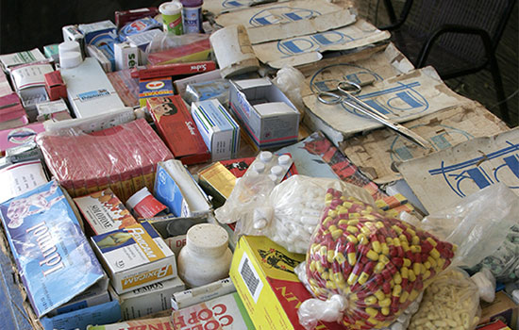 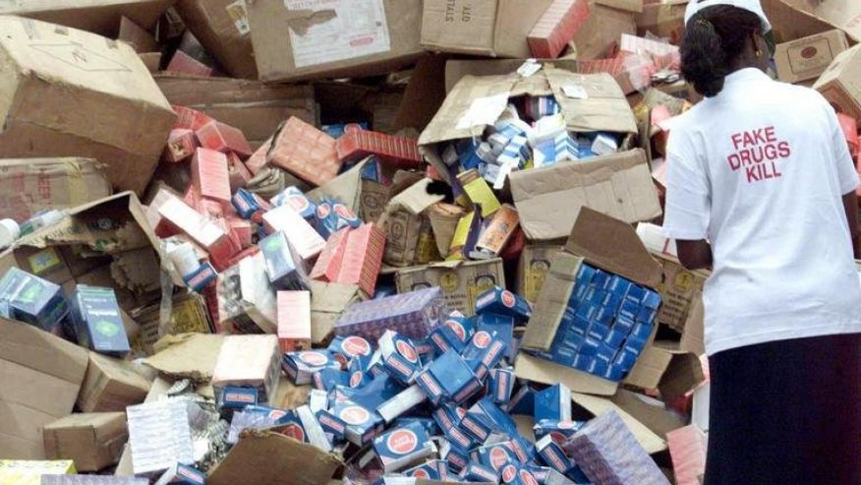

## **In food and beverages**

Past and present examples of adulteration, some dangerous, include:

* Roasted [chicory](https://en.wikipedia.org/wiki/Chicory) roots used as an adulterant for [coffee](https://en.wikipedia.org/wiki/Coffee)
* [Diethylene glycol](https://en.wikipedia.org/wiki/Diethylene_glycol), used dangerously by some winemakers in [sweet wines](https://en.wikipedia.org/wiki/Sweet_wine)
* [Apple](https://en.wikipedia.org/wiki/Apple) jellies (jams), as substitutes for more expensive fruit [jellies](https://en.wikipedia.org/wiki/Fruit_preserves), with added colorant and sometimes even specks of wood that simulate raspberry or strawberry seeds
* [Water](https://en.wikipedia.org/wiki/Water), for diluting [milk](https://en.wikipedia.org/wiki/Milk) and [alcoholic beverages](https://en.wikipedia.org/wiki/Alcoholic_beverage)
* [Cutting agents](https://en.wikipedia.org/wiki/Cutting_agent) used to adulterate (or "cut") illicit drugs—for example, [shoe polish](https://en.wikipedia.org/wiki/Shoe_polish) in [hashish](https://en.wikipedia.org/wiki/Hashish), [amphetamines](https://en.wikipedia.org/wiki/Amphetamine) in ecstasy, lactose in [cocaine](https://en.wikipedia.org/wiki/Cocaine)
* [Urea](https://en.wikipedia.org/wiki/Urea), [melamine](https://en.wikipedia.org/wiki/Melamine) and other no protein [nitrogen](https://en.wikipedia.org/wiki/Nitrogen) sources, added to [protein](https://en.wikipedia.org/wiki/Protein) products to inflate crude protein content measurements.
* [High fructose corn syrup](https://en.wikipedia.org/wiki/High_fructose_corn_syrup) or [cane sugar](https://en.wikipedia.org/wiki/Cane_sugar), used to adulterate [honey](https://en.wikipedia.org/wiki/Honey)
* Water or [brine](https://en.wikipedia.org/wiki/Brine) injected into chicken, pork, or other meats to increase their weight.

|  |  |  |  |  |  |
| --- | --- | --- | --- | --- | --- |
| |  | | --- | | **Effects of food adulteration on human health** | |  | |  | | While traditionally, Indian families used to cook food at home with healthy ingredients and knew what went into the meal, in modern times, with rising incomes and affluence, more and more people are moving away to readymade fast foods and eating regularly at restaurants. The food in many of these outlets is cooked with poor quality ingredients to attract and satisfy the palate rather than provide a wholesome nutritional meal. We now have a lot more varieties and the choices are many. Though, some of us may not be aware of the fact that the food we consume may be adulterated, 25 to 30 per cent of the food items in India are intentionally adulterated.  **Impure, unsafe** Food adulteration is the addition or removal of any substances to or from food, so that the natural composition and quality is affected. Adulterated food is impure, unsafe and not wholesome. Food can be adulterated intentionally and accidentally. Unintentional adulteration is a result of ignorance or the lack of facilities to maintain food quality. This may be caused by spillover effect from pesticides and fertilizers. Inappropriate food handling and packaging methods can also result in adulteration.  Intentional food adulteration is usually done for financial gain. The most common form of intentional adulteration is colour adulteration. Some examples of intentional adulteration are addition of water to liquid milk, extraneous matter to ground spices, or the removal or substitution of milk solids from the natural product. Natural adulteration occurs due to the presence of certain chemicals, organic compounds or radicals naturally occurring in foods which are injurious to health and are not added to the foods intentionally or unintentionally. Some of the examples are toxic varieties of pulses, mushrooms, green and other vegetables, fish and seafood. About 5,000 species of marine fish are known to be poisonous and many of these are among edible varieties.  **Beyond safety limit** Mineral oil may be added to edible oil and fats and can cause cancers. Lead chromate added to turmeric powder and spices can cause anemia, paralysis, brain damage and abortions. Lead added to water, natural and processed food can lead to lead poisoning. Lead poisoning causes foot drop, insomnia, constipation, anemia, and mental retardation. Cobalt added to water and liquors and can cause cardiac damage. Copper, tin and zinc can cause colic, vomiting and diarrhea. Mercury in mercury fungicide treated grains or mercury contaminated fish can cause brain damage, paralysis and death. Non-permitted colour or permitted food colour like metanil yellow, beyond the safe limit in coloured food can cause allergies, hyperactivity, liver damage, infertility, anemia, cancer and birth defects. | | http://www.fnbnews.com/images/33055chart.jpg **Adulteration In Food Stuff And Its Harmful Effects**   **Prevention** The best way to avoid these health problems is prevention. There are many steps we can take to ensure this. We can begin by taking interest in the place from where we buy our food ingredients, for example, is it from a reputed shop or retailer, we need to check out. We also need to check if these outlets are regularly checked by food inspectors and if the premises are kept clean with no infestations. We need to check if the packaging is intact, as also the expiry date and the source of the product. It is also necessary to talk regularly to the local community to check if people are falling sick after eating in a particular restaurant or food ingredients bought from a particular retailer. We should also create awareness in the local community on the ill effects of food adulteration so that when it happens the public knows when to seek help.  We need to remember that contamination could happen in very small amounts over a period of time and it might be impossible to detect or too late to intervene. So it is prudent that every one of us takes special interest in this subject and educate our families, friends and colleagues about this menace.   (The author is a consultant colorectal surgeon at Apollo Hospitals, Chennai. He is the lead clinician in the department of colorectal surgery and super specializes in surgical management of the diseases of the colon, rectum and anus). | |
|  |

**CLASS; J S S 1 WEEK 8** **TOPIC; BEAD WORKS**

# Bead

A **bead** is a small, decorative object that is formed in a variety of shapes and sizes of a material such as stone, bone, shell, glass, plastic, wood or pearl and that a small hole is drilled for [threading](https://en.wikipedia.org/wiki/Yarn) or stringing. Beads range in size from under 1 millimeter (0.039 in) to over 1 centimeter (0.39 in) in diameter. A pair of beads made from [*Nassarius*](https://en.wikipedia.org/wiki/Nassarius) sea snail shells, approximately 100,000 years old, are thought to be the earliest known examples of [jewelry](https://en.wikipedia.org/wiki/Jewellery) / jewelry.[Beadwork](https://en.wikipedia.org/wiki/Beadwork) is the art or craft of making things with beads. Beads can be woven together with specialized [thread](https://en.wikipedia.org/wiki/Yarn), strung onto thread or soft, flexible [wire](https://en.wikipedia.org/wiki/Wire), or adhered to a surface (e.g. [fabric](https://en.wikipedia.org/wiki/Cloth), [clay](https://en.wikipedia.org/wiki/Clay)

[Beadwork](https://en.wikipedia.org/wiki/Beadwork) is the art or craft of making things with beads. Beads can be woven together with specialized [thread](https://en.wikipedia.org/wiki/Yarn), strung onto thread or soft, flexible [wire](https://en.wikipedia.org/wiki/Wire).

## **Types of beads**

[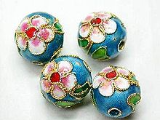](https://en.wikipedia.org/wiki/File:Cloisonnebeads.jpg) [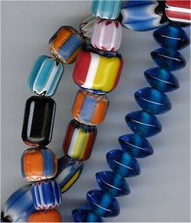](https://en.wikipedia.org/wiki/File:Beads.jpg)

Cloisonné beads

Beads may be divided into several types of overlapping categories based on different criteria such as the materials from which they are made, the process used in their manufacturing, the place or period of origin, the patterns on their surface, or their general shape. In some cases, such as [millefiori](https://en.wikipedia.org/wiki/Millefiori) and [cloisonné](https://en.wikipedia.org/wiki/Cloisonn%C3%A9) beads, multiple categories may overlap in an interdependent fashion.

## **Components**

Beads can be made of many different materials. The earliest beads were made of a variety of natural materials which, after they were gathered, could be readily drilled and shaped. As humans became capable of obtaining and working with more difficult materials, those materials were added to the range of available substances. More recently, synthetic materials were added.

In modern manufacturing, the most common bead materials are wood, [plastic](https://en.wikipedia.org/wiki/Plastic), [glass](https://en.wikipedia.org/wiki/Glass), [metal](https://en.wikipedia.org/wiki/Metal), and [stone](https://en.wikipedia.org/wiki/Rock_%28geology%29).

### **Natural materials**

Beads are still made from many naturally occurring materials, both organic (i.e., of [animal](https://en.wikipedia.org/wiki/Animal)- or [plant](https://en.wikipedia.org/wiki/Plant)-based origin) and inorganic (purely [mineral](https://en.wikipedia.org/wiki/Mineral) origin). However, some of these materials now routinely undergo some extra processing beyond mere shaping and drilling such as color enhancement via [dyes](https://en.wikipedia.org/wiki/Dyes) or irradiation.

The natural organics include [bone](https://en.wikipedia.org/wiki/Bone), [coral](https://en.wikipedia.org/wiki/Coral_%28precious%29), [horn](https://en.wikipedia.org/wiki/Horn_%28anatomy%29), [ivory](https://en.wikipedia.org/wiki/Ivory), [seeds](https://en.wikipedia.org/wiki/Seed) (such as [tagua](https://en.wikipedia.org/wiki/Tagua) nuts), [animal shell](https://en.wikipedia.org/wiki/Animal_shell), and [wood](https://en.wikipedia.org/wiki/Wood). For most of human history [pearls](https://en.wikipedia.org/wiki/Pearl) were the ultimate precious beads of natural origin because of their rarity; the modern [pearl-culturing process](https://en.wikipedia.org/wiki/Cultured_pearl) has made them far more common. [Amber](https://en.wikipedia.org/wiki/Amber) and [jet](https://en.wikipedia.org/wiki/Jet_%28lignite%29) are also of natural organic origin although both are the result of partial [fossilization](https://en.wikipedia.org/wiki/Fossil).

The natural inorganics include various types of [stones](https://en.wikipedia.org/wiki/Rock_%28geology%29), ranging from [gemstones](https://en.wikipedia.org/wiki/Gemstone) to common [minerals](https://en.wikipedia.org/wiki/Mineral), and [metals](https://en.wikipedia.org/wiki/Metal). Of the latter, only a few [precious metals](https://en.wikipedia.org/wiki/Precious_metal) occur in pure forms, but other purified [base metals](https://en.wikipedia.org/wiki/Base_metal) may as well be placed in this category along with certain naturally occurring alloys such as [electrum](https://en.wikipedia.org/wiki/Electrum). There are also paper beads.

### Synthetic materials

[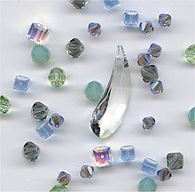](https://en.wikipedia.org/wiki/File:Crystbeads.jpg) [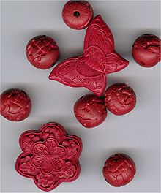](https://en.wikipedia.org/wiki/File:Cinnabarbead.jpg)

The oldest-surviving synthetic materials used for bead making have generally been [ceramics](https://en.wikipedia.org/wiki/Ceramic): [pottery](https://en.wikipedia.org/wiki/Pottery) and [glass](https://en.wikipedia.org/wiki/Glass). Beads were also made from ancient alloys such as [bronze](https://en.wikipedia.org/wiki/Bronze) and [brass](https://en.wikipedia.org/wiki/Brass), but as those were more vulnerable to [oxidation](https://en.wikipedia.org/wiki/Oxidation) they have generally been less well-preserved at archaeological sites.

Many different subtypes of [glass](https://en.wikipedia.org/wiki/Glass) are now used for bead making, some of which have their own component-specific names. [Lead crystal](https://en.wikipedia.org/wiki/Lead_crystal) beads have a high percentage of [lead oxide](https://en.wikipedia.org/wiki/Lead%28II%29_oxide) in the glass formula, increasing the [refractive index](https://en.wikipedia.org/wiki/Refractive_index). Most of the other named glass types have their formulations and patterns inseparable from the manufacturing process.

Small, colourful, fusible plastic beads (some brands are Nabbi, Hama, Perler, and Pyssla) can be placed on a solid plastic-backed peg array to form designs and then melted together with a [clothes iron](https://en.wikipedia.org/wiki/Ironing); alternatively, they can be strung into necklaces and bracelets or woven into keychains. Fusible beads come in many colors and degrees of [transparency](https://en.wikipedia.org/wiki/Transparency_and_translucency)/[opacity](https://en.wikipedia.org/wiki/Opacity_%28optics%29), including varieties that glow in the dark or have internal [glitter](https://en.wikipedia.org/wiki/Glitter); peg boards come in various shapes and several geometric patterns. Plastic toy beads, made by chopping plastic tubes into short pieces, were introduced in 1958 by Munkplast AB in [Munka-Ljungby](https://en.wikipedia.org/wiki/Munka-Ljungby), Sweden, under the brand Nabbi. Known as [Indian beads](https://en.wikipedia.org/wiki/Indian_bead), they were originally sewn together to form ribbons.

## **Place or period of origin.**

Carved [Cinnabar](https://en.wikipedia.org/wiki/Cinnabar) [lacquer](https://en.wikipedia.org/wiki/Lacquer) beads

**African trade beads** or [**slave beads**](https://en.wikipedia.org/wiki/Slave_beads) may be antique beads that were manufactured in Europe and used for trade during the colonial period, such as chevron beads; or they may have been made in West Africa by and for Africans, such as Mauritanian [Kiffa beads](https://en.wikipedia.org/wiki/Kiffa_beads), Ghanaian and Nigerian [powder glass beads](https://en.wikipedia.org/wiki/Powder_glass_beads), or African-made brass beads.

**Austrian crystal** is a generic term for cut lead-crystal beads, based on the location and prestige of the [Swarovski](https://en.wikipedia.org/wiki/Swarovski) firm.

**Czech glass** beads are made in the [Czech Republic](https://en.wikipedia.org/wiki/Czech_Republic), in particular an area called [Jablonec and Nisou](https://en.wikipedia.org/wiki/Jablonec_nad_Nisou). Production of glass beads in the area dates back to the 14th century, though production was depressed under communist rule. Because of this long tradition, their workmanship and quality has an excellent reputation.

**Vintage beads**, in the collectibles and antique market, refers to items that are at least 25 or more years old. Vintage beads are available in materials that include lucite, plastic, crystal, metal and glass.

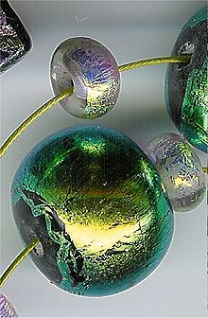 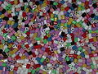 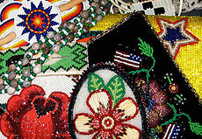

## **Components**

Beads can be made of many different materials. The earliest beads were made of a variety of natural materials which, after they were gathered, could be readily drilled and shaped. As humans became capable of obtaining and working with more difficult materials, those materials were added to the range of available substances. More recently, synthetic materials were added.

In modern manufacturing, the most common bead materials are wood, [plastic](https://en.wikipedia.org/wiki/Plastic), [glass](https://en.wikipedia.org/wiki/Glass), [metal](https://en.wikipedia.org/wiki/Metal), and [stone](https://en.wikipedia.org/wiki/Rock_(geology)).

## **Symbolic meaning of bead.**

In many parts of the world, beads are used for symbolic purposes, for example:

* use for prayer or devotion - e.g. [rosary beads](https://en.wikipedia.org/wiki/Rosary_beads) for Roman Catholics, [misbaha](https://en.wikipedia.org/wiki/Misbaha) for Muslims
* use for anti-tension devices, e.g. [worry beads](https://en.wikipedia.org/wiki/Worry_beads)
* use as currency e.g. [Aggrey beads](https://en.wikipedia.org/wiki/Aggrey_beads) from [Ghana](https://en.wikipedia.org/wiki/Ghana)
* use for gaming e.g. [owari beads](https://en.wikipedia.org/w/index.php?title=Owari_beads&action=edit&redlink=1) for [Makala](https://en.wikipedia.org/wiki/Mankala)
* Greek [komboloi](https://en.wikipedia.org/wiki/Komboloi) beads as in [Crete](https://en.wikipedia.org/wiki/Crete).

## **History of Beads.**

Beads are known to be one of earliest forms of trade between the human race. It is thought that is because of bead trading that humans developed language. Beads are said to have been used and traded for most of our history. The oldest beads found to date were at [Ksar Akil](https://en.wikipedia.org/wiki/Ksar_Akil), in Lebanon. Prior to this find, the beads found in the [Blombos Cave](https://en.wikipedia.org/wiki/Blombos_Cave) were the oldest at about 72,000 years old.

## **Surface patterns.**

After shaping, glass and crystal beads can have their surface appearance enhanced by etching a translucent frosted layer, applying an additional colour layer, or both. *Aurora Borealis*, or AB, is a surface coating that diffuses light into a rainbow. Other surface coatings are vitrail, moonlight, Dorado, satin, star shine, and heliotrope.

Faux beads are beads that are made to look like a more expensive original material, especially in the case of fake [pearls](https://en.wikipedia.org/wiki/Pearl) and simulated rocks, [minerals](https://en.wikipedia.org/wiki/Minerals) and [gemstones](https://en.wikipedia.org/wiki/Gemstone). Precious metals and [ivory](https://en.wikipedia.org/wiki/Ivory) are also imitated.

[Tagua nuts](https://en.wikipedia.org/wiki/Tagua_nut) from South America are used as an ivory substitute since the natural [ivory trade](https://en.wikipedia.org/wiki/Ivory_trade) has been restricted worldwide.

**CLASS; J S S 1 WEEK 9**

**TOPIC;** **AFRICAN MUSICAL INSTRUMENTS.**

# **Music of Africa**

[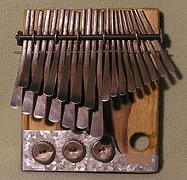](https://en.wikipedia.org/wiki/File:Mbira_dzavadzimu.jpg)

The [lamellophone](https://en.wikipedia.org/wiki/Lamellophone) [thumb piano](https://en.wikipedia.org/wiki/Thumb_piano) or [mbira](https://en.wikipedia.org/wiki/Mbira), a popular instrument in the African

**The traditional music of Africa,** given the vastness of the continent, is historically ancient, rich and diverse, with different [regions](https://en.wikipedia.org/wiki/Regions_of_Africa) and [nations](https://en.wikipedia.org/wiki/List_of_African_countries) of [Africa](https://en.wikipedia.org/wiki/Africa) having many distinct musical traditions.

Traditional music in most of the continent is passed down orally (or aurally) and is not written. In [Sub-Saharan African music traditions](https://en.wikipedia.org/wiki/Sub-Saharan_African_music_traditions), it frequently relies on percussion instruments of every variety, including [xylophones](https://en.wikipedia.org/wiki/Xylophone), [drums](https://en.wikipedia.org/wiki/Drums), and tone-producing instruments such as the [mbira](https://en.wikipedia.org/wiki/Mbira) or "thumb piano.

The music and dance of the [African diaspora](https://en.wikipedia.org/wiki/African_diaspora), formed to varying degrees on African musical traditions, include [American music](https://en.wikipedia.org/wiki/Music_of_the_United_States) and many [Caribbean](https://en.wikipedia.org/wiki/Caribbean_music) genres, such as [Soca](https://en.wikipedia.org/wiki/Soca_music),[Calypso](https://en.wikipedia.org/wiki/Calypso_music) (see [kaiso](https://en.wikipedia.org/wiki/Kaiso)) and [Zouk](https://en.wikipedia.org/wiki/Zouk). [Latin American music](https://en.wikipedia.org/wiki/Latin_American_music) genres such as the [Bachata](https://en.wikipedia.org/wiki/Bachata_(music)),[Danzón](https://en.wikipedia.org/wiki/Danz%C3%B3n), [Samba](https://en.wikipedia.org/wiki/Samba), [Rumba](https://en.wikipedia.org/wiki/Rumba), [Salsa](https://en.wikipedia.org/wiki/Salsa_music), [Tango](https://en.wikipedia.org/wiki/Tango), [Cumbia](https://en.wikipedia.org/wiki/Cumbia), [Bomba del Chota](https://en.wikipedia.org/wiki/Bomba_(Ecuador)), [Mambo](https://en.wikipedia.org/wiki/Mambo_(dance)), [Merengue](https://en.wikipedia.org/wiki/Merengue_(dance)),[Reggae](https://en.wikipedia.org/wiki/Reggae), [Compas](https://en.wikipedia.org/wiki/Compas), [Milonga](https://en.wikipedia.org/wiki/Milonga_(dance)), [Son](https://en.wikipedia.org/wiki/Son_(music)), [Guaracha](https://en.wikipedia.org/wiki/Guaracha), [Punta](https://en.wikipedia.org/wiki/Punta), [Cha-Cha-Cha](https://en.wikipedia.org/wiki/Cha-cha-cha_(dance)), [Plena](https://en.wikipedia.org/wiki/Plena), [Conga](https://en.wikipedia.org/wiki/Conga), and other [clave (rhythm)](https://en.wikipedia.org/wiki/Clave_(rhythm))-based genres, were also founded on the music of [enslaved Africans](https://en.wikipedia.org/wiki/African_slave_trade), and have in turn influenced [African popular music](https://en.wikipedia.org/wiki/African_popular_music).

## **AFRICAN MUSICAL INSTRUMENTS**

The African culture is one of the best culture all over the world.

This culture have many parts and styli  which varies from different parts and location.

This include Dance steps, Dressing, Food etc. But today i will be showing you some great African musical instrument with their name and pictures with little note on each of them.

**[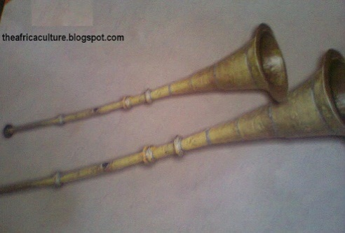](http://1.bp.blogspot.com/-X8dbIi5otQY/TzlUu-8_qyI/AAAAAAAAAME/wS-R-0DCvZo/s1600/Photo0179.jpg)**

**This an African local Trumpet  also known as Kaakaki**

The kaakaki is a long trumpet made of brass that flares out at the tail.

The kaakaki is a must play in royal invents IN northern Nigeria. Aside celebrations the kaakaki is hard during the arrival or departure of the Emir(His royal highness) The kaakaki also has a pride of place in royal durbars.

**[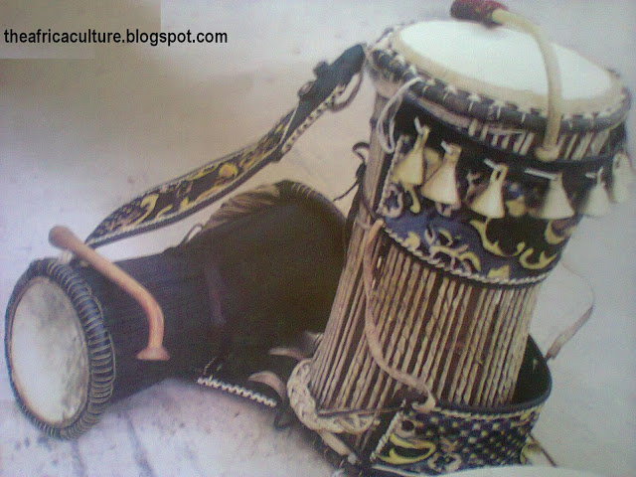](http://1.bp.blogspot.com/-W_fPxoM6prA/TzlVC5uY2DI/AAAAAAAAAMM/IfR80P5Hqqs/s1600/Photo0165.jpg)**

**Talking Drum local name Gangan or Kalangu**

The Talking drum: This is one off the most respected drum in (Gangan) southern Nigeria, similar to the Kalangu Drum from Northern Nigeria. In the south, this drum lead most of the musical instrument (Depending on the dance steps) dictating the pace and melody of the music; It's biggest strength is the ability to communicate between the singers, the audience and the band.

The sound of this give direction to the dancers on what to do at a given time.

[**[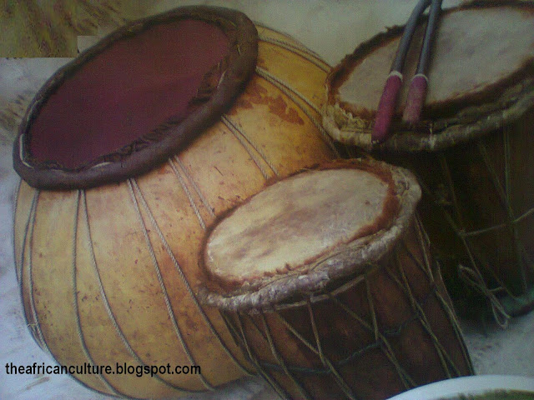](http://2.bp.blogspot.com/-sAgoGuxWalc/TzlVx6R2-fI/AAAAAAAAAMU/OpYb3k9u9I8/s1600/Photo0166.jpg)**](http://2.bp.blogspot.com/-sAgoGuxWalc/TzlVx6R2-fI/AAAAAAAAAMU/OpYb3k9u9I8/s1600/Photo0166.jpg)

**Drums local name: Thunder and Duma**

Duma is a set of ceremonial drums used for dances, weddings and general entertainment. The drums are made from woods, calabash and animal hide. They are usually struck with palm or with drum sticks. They are mostly found in the North and occasionally in the Eastern part of Nigeria.

**[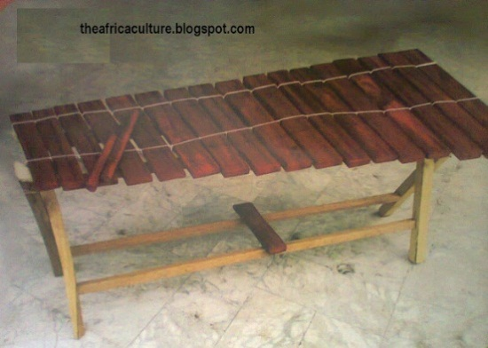](http://2.bp.blogspot.com/-hhg8Tne2i_Y/TzlWx0_7bmI/AAAAAAAAAMk/pimyWdP8gwA/s1600/Photo0167.jpg)**

**XYLOPHONE LOCAL NAME: NGELENGE OR IKON(NIGERIA)**

Xylophone or ngelenge is a traditional xylophone made from hard woods.

When struck with two sticks, it produces different notes depending on the part that was struck. It is found in many parts of the southern Nigeria. The instrument is generally used as a musical accompaniment.

**[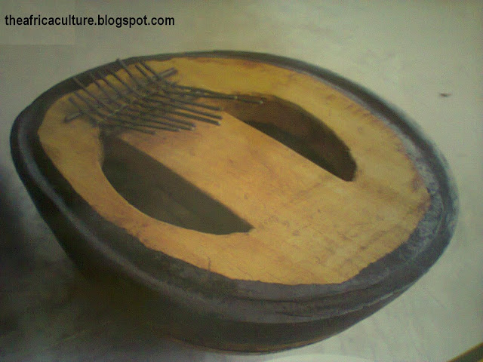](http://4.bp.blogspot.com/-eEob-O4IywU/TzlWhq58XrI/AAAAAAAAAMc/307OCbwc9sg/s1600/Photo0168.jpg)**  
**THUMB PIANO LOCAL NAME: UBO (Igbo)**

Ubo is made from one half of a gourd or calabash with little stripes of toughened metals attached to a flat panel on top. A hole is cut in the calabash for grip. Sounds escape when the strips of steel are tugged at, mainly with the thumb, creating melodious tunes.

**[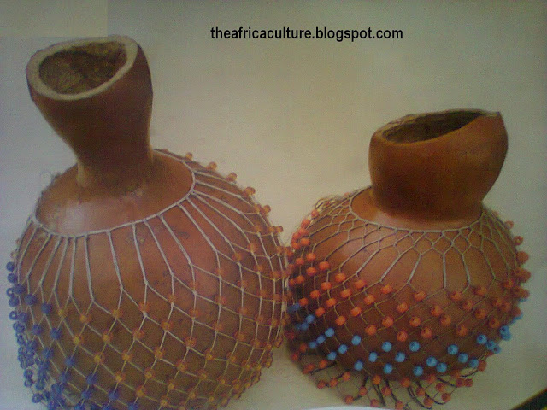](http://1.bp.blogspot.com/-yjD3snKlC4w/TzlYnTMcmVI/AAAAAAAAAMs/Tyq9Ak5RSng/s1600/Photo0169.jpg)**

**MARACAS LOCAL NAME: SEKERE, ICHAKA (NIGERIA)**

This is a vital musical instrument in most part of the southern and eastern Nigeria.

This rattle is called sakere in yoruba, ichaka in Igbo and Idoma language. It is made of gourd or calabash loosely covered with beads. When tapped or shaken it produces a rattling sound to compliment other instruments.

**[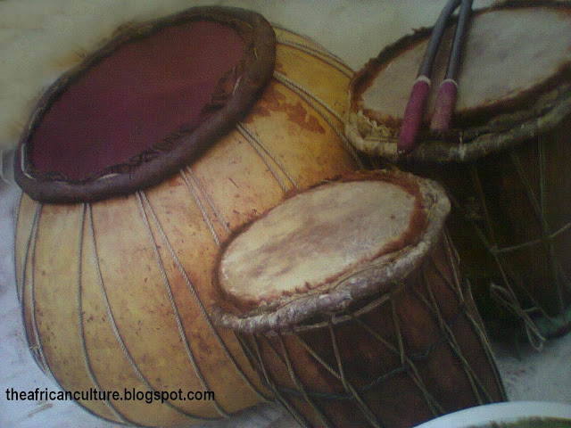](http://4.bp.blogspot.com/-YJFjjJOFJiI/T0vI-kGmZuI/AAAAAAAAAM4/YOD_YaOqCmU/s1600/Photo0166.jpg)**

**WATER POT DRUMS LOCAL NAME: NGU(IGBO)**

These are set of pots usually clay. They come in varying sizes and are filled with water to different levels, when the open top is struck with plat padded wood, each pot produces different sounds and create tunes. This instrument is mostly found in igbo speaking areas Nigeria.

**[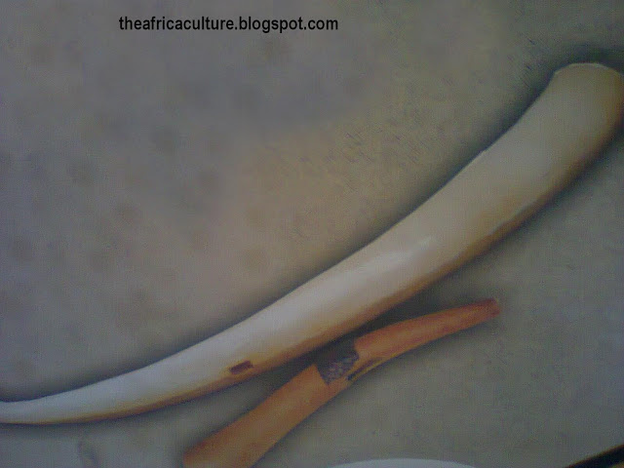](http://2.bp.blogspot.com/-LX8AKwkUXg0/T0vJM1tCemI/AAAAAAAAANA/bhr7IbaLZf8/s1600/Photo0172.jpg)**

**HORN LOCAL NAMES OPI/OGBA, OBU-KPONG**

The horn, called Obu, Opi or  Ogba by different ethnic groups in southern Nigeria is made from animal horn or elephant tusk. It has an opening at the edge for producing sound as air is forced through it. The horn heralds the arrival or departure of the Igwe,Oba or a big masquerade.

**[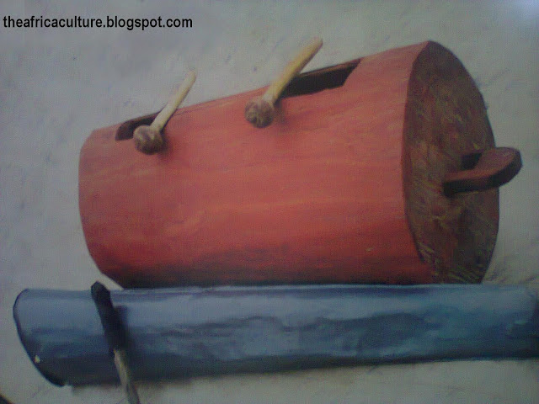](http://4.bp.blogspot.com/-Ykl-4KSiuFw/T0vJYMOyq-I/AAAAAAAAANI/qWCMWT881Bw/s1600/Photo0174.jpg)**

**GONGS (METAL - OGENE, WOODEN - IKORO)**

The ogene is from the Igbo speaking people of south - Eastern Nigeria. It is similar to the smaller version known as Agogo in the south Western Nigeria.It is made out of brass and stuck with a stick. The Ikoro, is a bigger version of the hand held wooden Gong Ekwe, but produces a deeper tone in accordance with its size.

[**[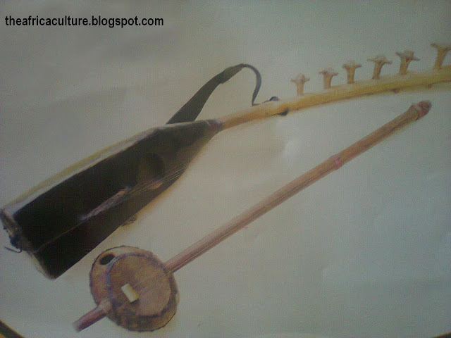](http://4.bp.blogspot.com/-eYPcVXPMtHI/T0vKIhk9peI/AAAAAAAAANQ/QqZdlymTcqA/s1600/Photo0175.jpg)**](http://4.bp.blogspot.com/-eYPcVXPMtHI/T0vKIhk9peI/AAAAAAAAANQ/QqZdlymTcqA/s1600/Photo0175.jpg)

**Guitar Local name: Molo, Grumi**

Grumi is a traditional two sringed guiter from the northern part of Nigeria. It is made of alligatoe skin, calabash, brass and wood . Its light, which makes it easy to hold up and play. Molo is a bigger type made from wood, unlike the Grumi, its heavy, so its worn around the neck or shoulder. It has a higher tune.

**[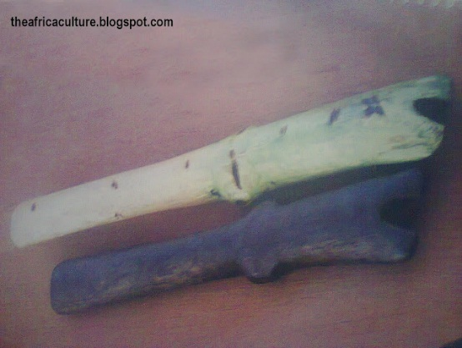](http://2.bp.blogspot.com/-6FEM9EBt2hU/T0vKyUNTdtI/AAAAAAAAANY/nbuKn6gRewk/s1600/Photo0177.jpg)**

**Flute lacal Name: Oja**

The oja flutes are common amongst th Igbo speaking people of the Eastern Nigeria. It is a woodwind instrument that comes in faur variants with difined treble,alto,teno and bass tones. It is most used in dance performances.

**[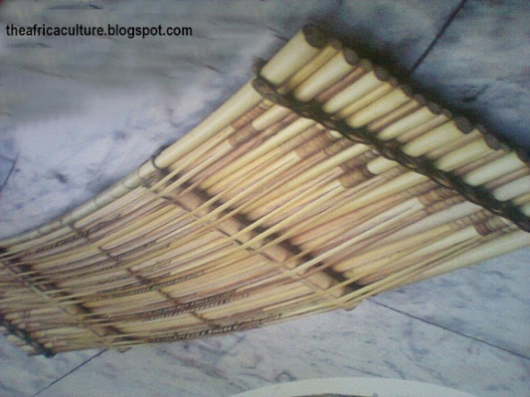](http://2.bp.blogspot.com/-t1-X7mNSXWo/T0vLKxlXJCI/AAAAAAAAANg/OsM2dqrmFZU/s1600/Photo0178.jpg)**

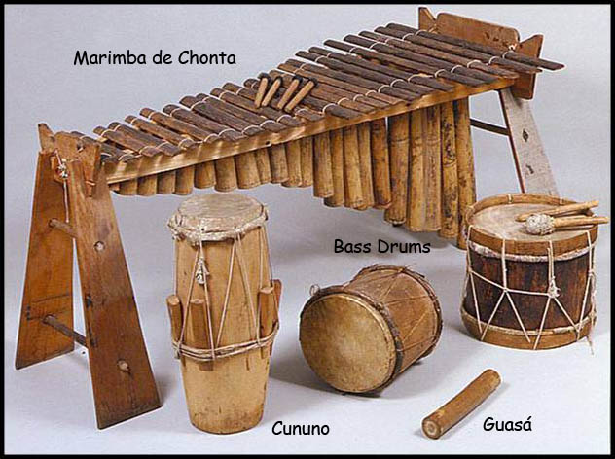 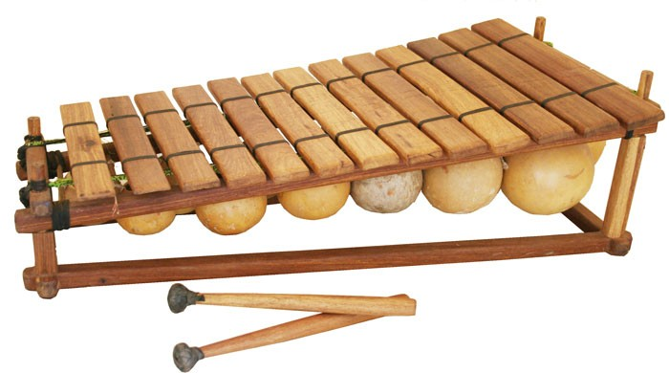

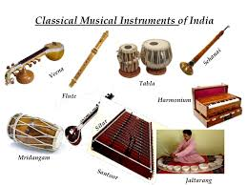 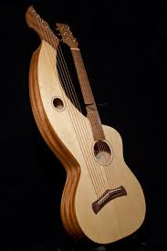

**CLASS; J S S 1 WEEK 10**

**TOPIC; TIE – DYE.**

**Tie-dye** is a modern term invented in the mid-1960s in the United States for a set of ancient [resist-dyeing](https://en.wikipedia.org/wiki/Resist_dyeing) techniques, and for the products of these processes. The process of tie-dye typically consists of folding, twisting, pleating, or crumpling fabric or a garment and binding with string or rubber bands, followed by application of dye(s). The manipulations of the fabric prior to application of dye are called resists, as they partially or completely prevent the applied dye from coloring the fabric. More sophisticated tie-dyes involve additional steps, including an initial application of dye prior to the resist, multiple sequential dye and resist steps, and the use of other types of resists (stitching, stencils) and discharge.

Tie-dyeing was known in the US by 1909, when Professor Charles E. Pellow of [Columbia University](https://en.wikipedia.org/wiki/Columbia_University) acquired some samples of tie-dyed [muslin](https://en.wikipedia.org/wiki/Muslin) and subsequently gave a lecture and live demonstration of the technique.

Although shibori and [batik](https://en.wikipedia.org/wiki/Batik) techniques were used occasionally in Western fashion before the 1960s, modern psychedelic tie-dying did not become a fad until the late 1960s following the example set by rock stars such as [Janis Joplin](https://en.wikipedia.org/wiki/Janis_Joplin) and [John Sebastian](https://en.wikipedia.org/wiki/John_Sebastian) (who did his own dyeing). The 2011 film documentary [*Magic Trip*](https://en.wikipedia.org/wiki/Magic_Trip), which shows amateur film footage taken during the 1964 cross-country [bus journey](https://en.wikipedia.org/wiki/Further_(bus)) of [countercultural icon](https://en.wikipedia.org/wiki/Counterculture_of_the_1960s) [Ken Kasey](https://en.wikipedia.org/wiki/Ken_Kesey) and his [Merry Pranksters](https://en.wikipedia.org/wiki/Merry_Pranksters), shows the travelers developing a form of tie-dye by taking [LSD](https://en.wikipedia.org/wiki/Lysergic_acid_diethylamide) beside a pond and pouring enamel-based model airplane paint into it, before placing a white T-shirt upon the surface of the water. Although the process is closer to [paper marbling](https://en.wikipedia.org/wiki/Paper_marbling), in the accompanying narrative, the travelers claim credit for inventing tie-dyeing.

Dyes, fabrics, and discharge agents

A variety of dyes can be used in tie-dyeing, including household, fiber reactive, acid, and vat dyes. Most early (1960s) tie-dyes were made with retail household dyes, particularly those made by Rit. In order to be effective on different fibers, these dyes are composed of several different dyes, and thus are less effective, and more likely to bleed and fade, than pure dyes designed for specific fibers. This is the basis for the famous 'pink socks' phenomenon that occurs when fabrics dyed with mixed dyes are washed with other garments. Most tie-dyes are now dyed with [Procion](https://en.wikipedia.org/wiki/Procion) MX fiber [reactive dyes](https://en.wikipedia.org/wiki/Reactive_dyes), a class of dyes effective on [cellulose fibers](https://en.wikipedia.org/wiki/Cellulose_fiber) such as cotton, hemp, rayon, and linen. This class of dyes reacts with fibers at [basic (high) pH](https://en.wikipedia.org/wiki/Base_(chemistry)), forming a wash-fast, permanent bond. Soda ash ([sodium carbonate](https://en.wikipedia.org/wiki/Sodium_carbonate)) is the most common agent used to raise the [pH](https://en.wikipedia.org/wiki/PH) and initiate the reaction, and is either added directly to the dye, or in a solution of water in which garments are soaked before dying. Procion dyes are relatively safe and simple to use,[[6]](https://en.wikipedia.org/wiki/Tie-dye#cite_note-6) and are the same dyes used commercially to color cellulosic fabrics.

**CLASS; J S S 1 WEEK 11**

**TOPIC; PLAYING OF MUSICAL INSTRUMENTS.**

# **Benefits of Playing a Musical Instrument**

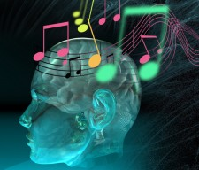

The Chinese philosopher Confucius said long ago that “Music produces a kind of pleasure which human nature cannot do without.” Playing a musical instrument has many benefits and can bring joy to you and to everyone around you.  This article will provide you with 18 benefits of playing an instrument (in no particular order) and will hopefully give you a better sense of appreciation and pride for music.

**1.  Increases the capacity of your memory.**  
Research has shown that both listening to music and playing a musical instrument stimulate your brain and can increase your memory.  A study was done in which 22 children from age 3 to 4 and a half years old were given either singing lessons or keyboard lessons.  A control group of 15 children received no music lessons at all. Both groups participated in the same preschool activities.  The results showed that preschoolers who had weekly keyboard lessons improved their spatial-temporal skills 34 percent more than the other children.  Not only that, but researchers said that the effect lasted long-term.

According to an article from The Telegraph online magazine, “New research suggests that regularly playing an instrument changes the shape and power of the brain and may be used in therapy to improve cognitive skills.”  There is continually more evidence that musicians have organizationally and functionally different brains compared to non-musicians, especially in the areas of the brain used in processing and playing music.  If you learn how to play an instrument, the parts of your brain that control motor skills (ex: using your hands, running, swimming, balancing, etc.), hearing, storing audio information, and memory actually grow and become more active.  Other results show that playing an instrument can help your IQ increase by seven points.

**2.  Refines your time management and organizational skills.**  
Learning how to play an instrument requires you to really learn how to be organized and to manage your time wisely.  A good musician knows that the quality of practice time is more valuable than the quantity.  In order for a musician to progress quicker, he/she will learn how to organize his/her practice time and plan different challenges to work on, making efficient use of time.

**3.  Boosts your team skills.**  
Team skills are a very important aspect of being successful in life.  Playing an instrument requires you to work with others to make music.  In band and orchestra settings you must learn how to cooperate with the people around you.  Also, in order for a group to make beautiful music, each player and section must learn how to listen to each other and play together.

**4.  Teaches you perseverance.**  
Learning to play an instrument takes time and effort, which really teaches you patience and perseverance.  Most people can’t play every piece of music perfectly the first time.  In fact, the majority of musicians have to work difficult sections of music multiple times in a row before they can play it correctly.

**5.  Enhances your coordination.**  
The art of playing an instrument requires a lot of hand-eye coordination.  By reading musical notes on a page, your brain subconsciously must convert that note into specific motor patterns while also adding breathing and rhythm to the mix.

**6.  Betters your mathematical ability.**  
Reading music requires counting notes and rhythms and can help your math skills.  Also, learning music theory includes many mathematical aspects.  Studies have shown that students who play instruments or study the arts are often better in math and achieve higher grades in school than students who don’t.  (Source: Friedman, B. (1959) An evaluation of the achievement in reading and arithmetic of pupils in elementary schools instrumental classes. Dissertation Abstracts International, 20, p p. s 3662-3663.)

**7.  Improves your reading and comprehension skills.**  
According to a study published in the journal Psychology of Music, “Children exposed to a multi-year program of music tuition involving training in increasingly complex rhythmic, tonal, and practical skills display superior cognitive performance in reading skills compared with their non-musically trained peers.”

It’s not surprising to hear results like that because music involves constant reading and comprehension.  When you see black and white notes on a page, you have to recognize what the note name is and translate it to a finger/slide position.  At the same time, you also have to read what rhythms the notes are arranged in and force your tongue to produce the correct pattern.

**8.  Increases your responsibility.**  
Playing an instrument comes with its responsibilities.  Maintenance and care are very important in keeping an instrument in working condition.  Each instrument has different procedures to keep in functioning properly, but most instruments need cleaning and some form of oiling/greasing.  In addition to maintenance responsibilities, there are other aspects such as remembering music events (like rehearsals and performances) and making time to practice.

**9.  Exposes you to cultural history.**  
Oftentimes music reflects the environment and times of its creation.  Therefore, you learn a variety of music types such as classical traditions, folk music, medieval, and other genres.  Music itself is history, and each piece usually has its own background and storyline that can further your appreciation of other cultures.

**10.  Sharpens your concentration.**  
Playing music by yourself requires you to concentrate on things like pitch, rhythm, tempo, note duration, and quality of sound.  Playing music in a group involves even more concentration because you must learn to not only hear yourself, but you must listen to all the other sections and play in harmony with the rest of the group.